Contents

Create Security Token in SQHUB 2

Update SQHUB token in secrets.yml for automation script 4

Update qa-pipeline.yml file for QA script 5

Fly Commands to create pipeline in Concourse server 11

# Create Security Token in SQHUB

**SQHUB URL:** <http://sqhub.homedepot.com/logoutSuccess>

In SQHUB home page, click on “Generate Token” button

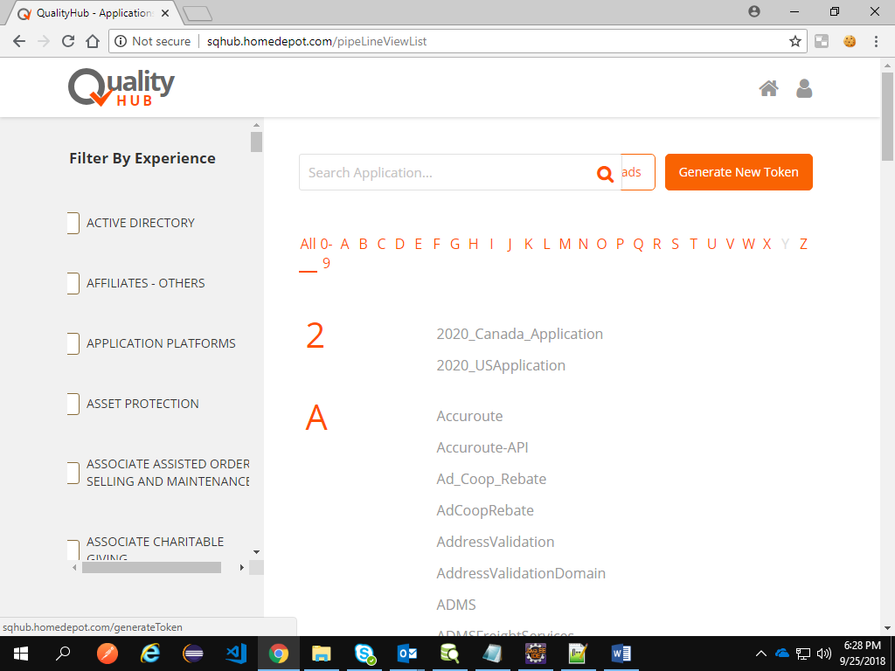

Provide Application Name, Experience Name and Email ID and click Generate Token

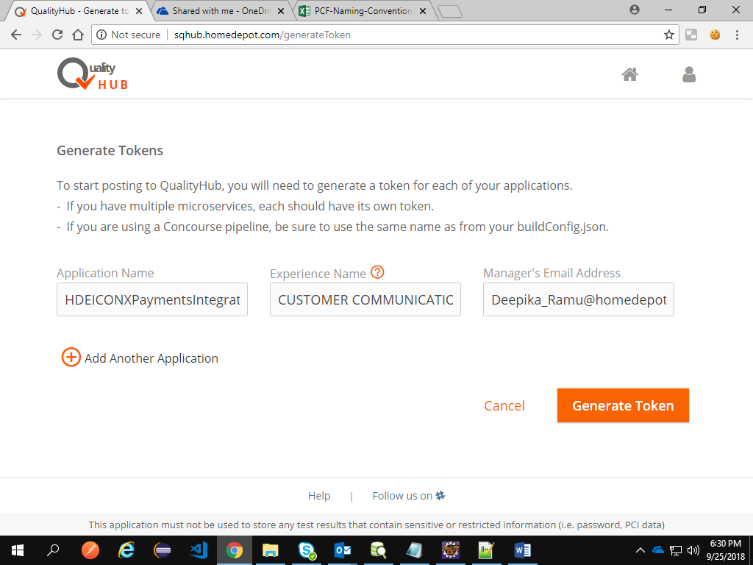

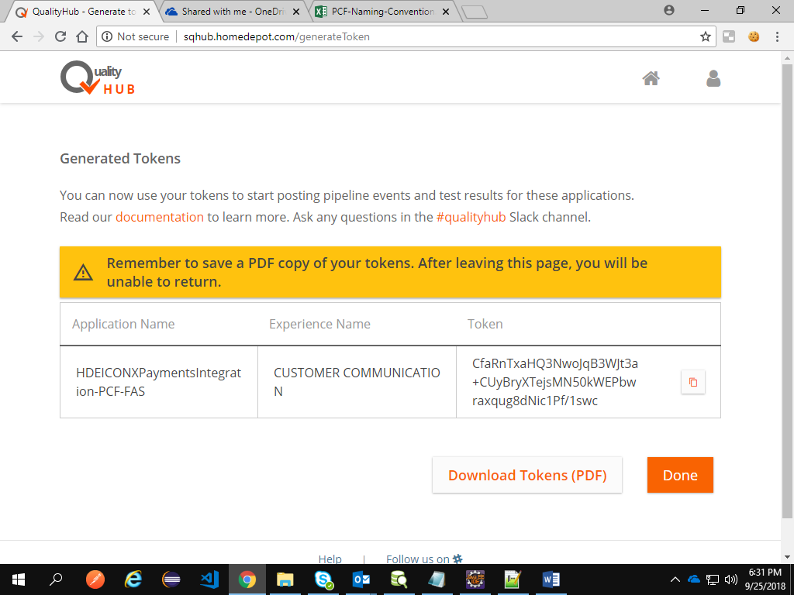

# Update SQHUB token in secrets.yml for automation script

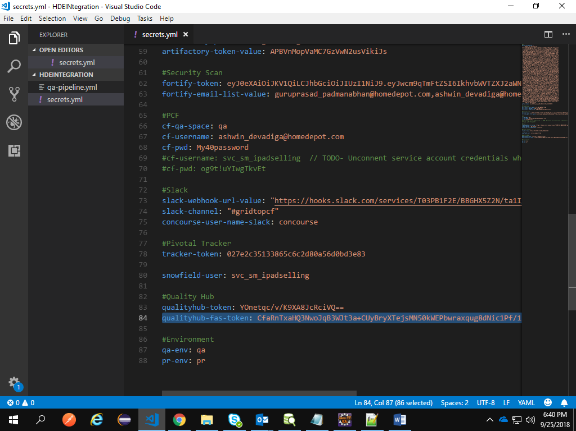

Please find below sample secrets.yml file



# Update qa-pipeline.yml file for QA script

1. Wherever you find repo name. Rename it according to your project. This qa-pipeline.yml has the comments to create pipeline in Concourse. So we have to create repo for Dev code and QA script separately. Basically repo will create space in that concourse server.

**Note:** In yml file, if there is any mismatch even in single indent then also there will be problem in creating the pipeline. Hence please make sure there is no unwanted space.

Please update as per the below screenshot.

1. Update Dev repo in the below line. Following to that add Dev git URL.

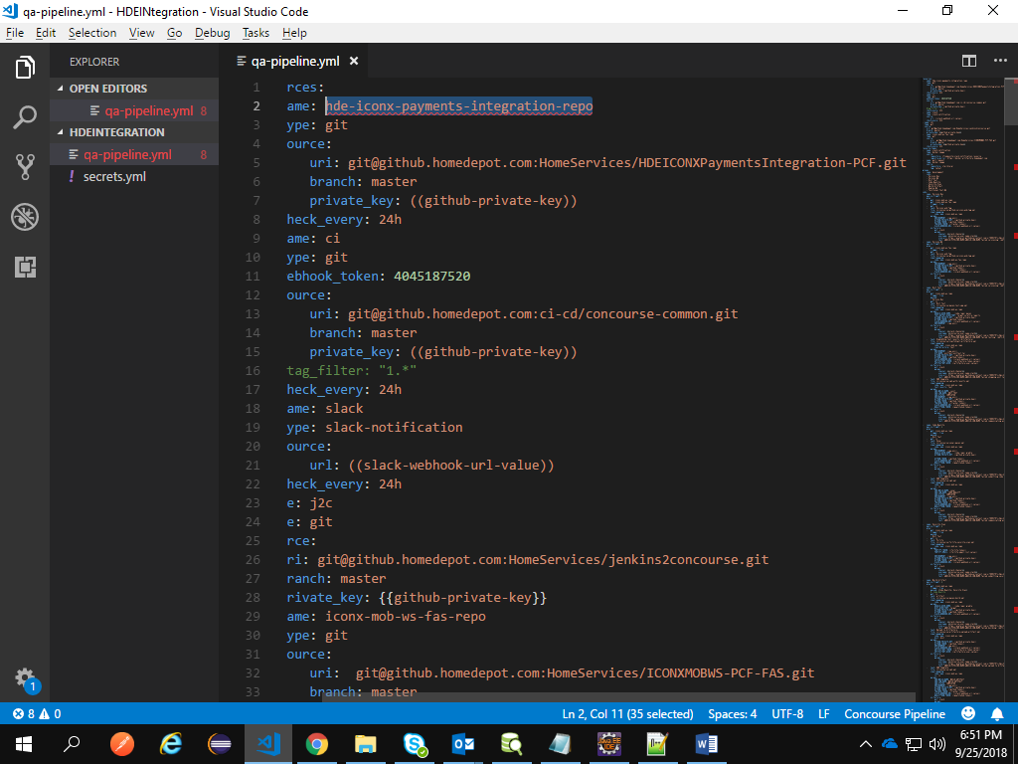

1. Update QA script repo name in the line # 29 and followed to that update QA script git URL.

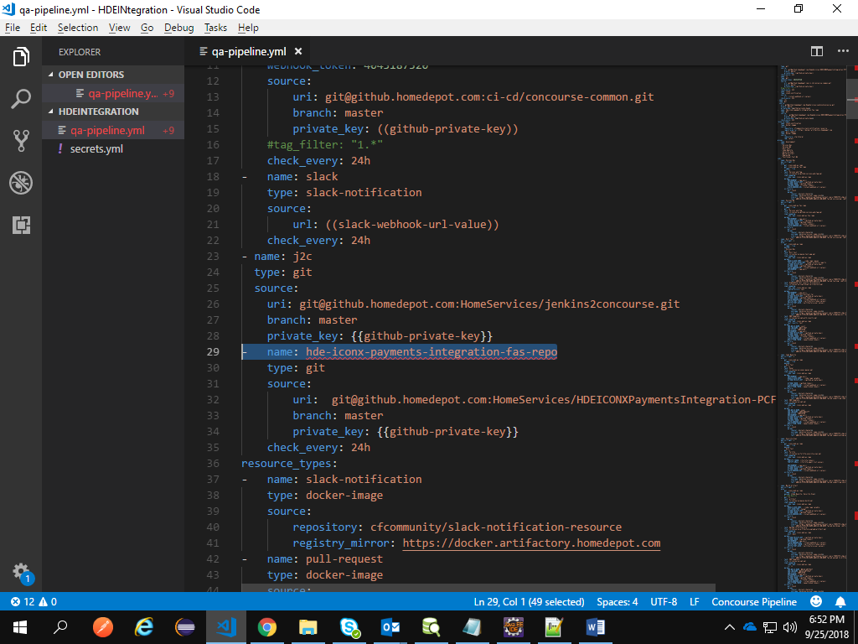

1. Update the repo name given in Step 1 and 2 in the line # 62 and 63

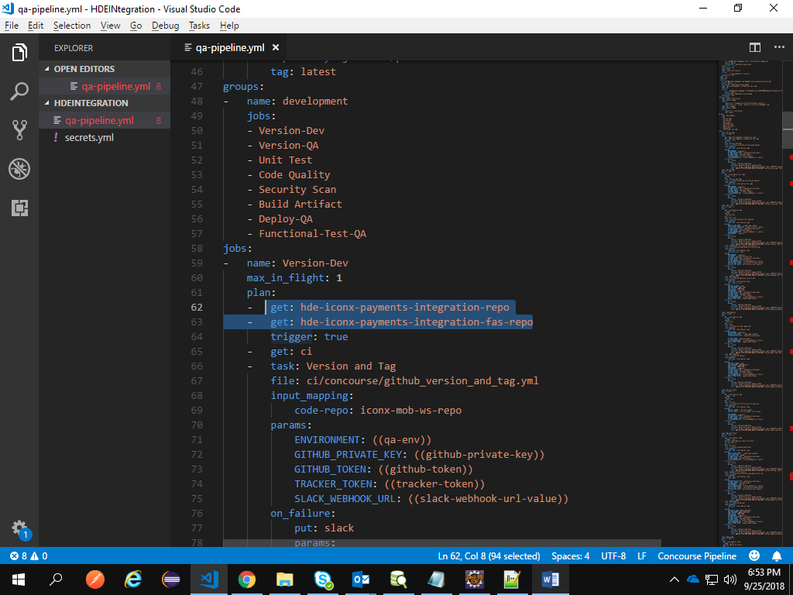

1. Update Dev code repo name in line # 69

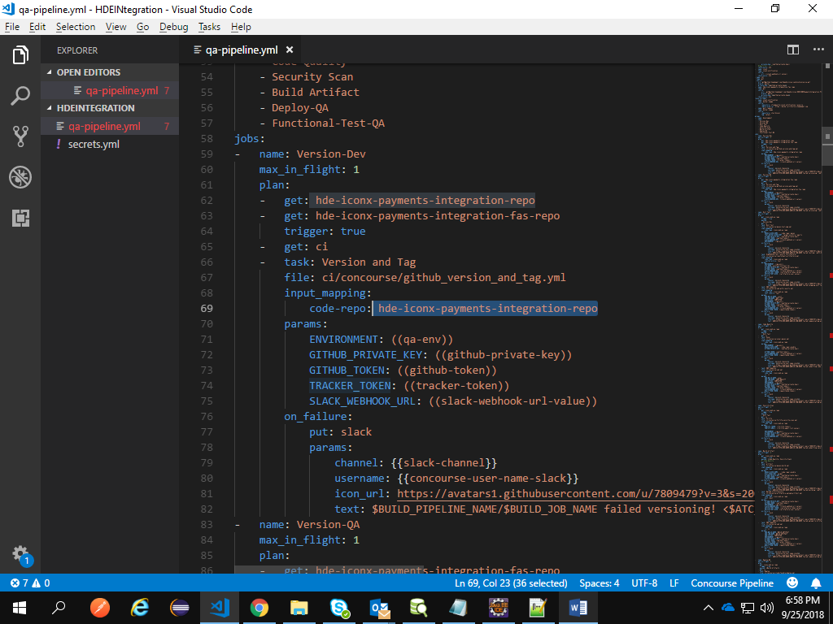

1. Update QA script repo name in line # 86 and 92.

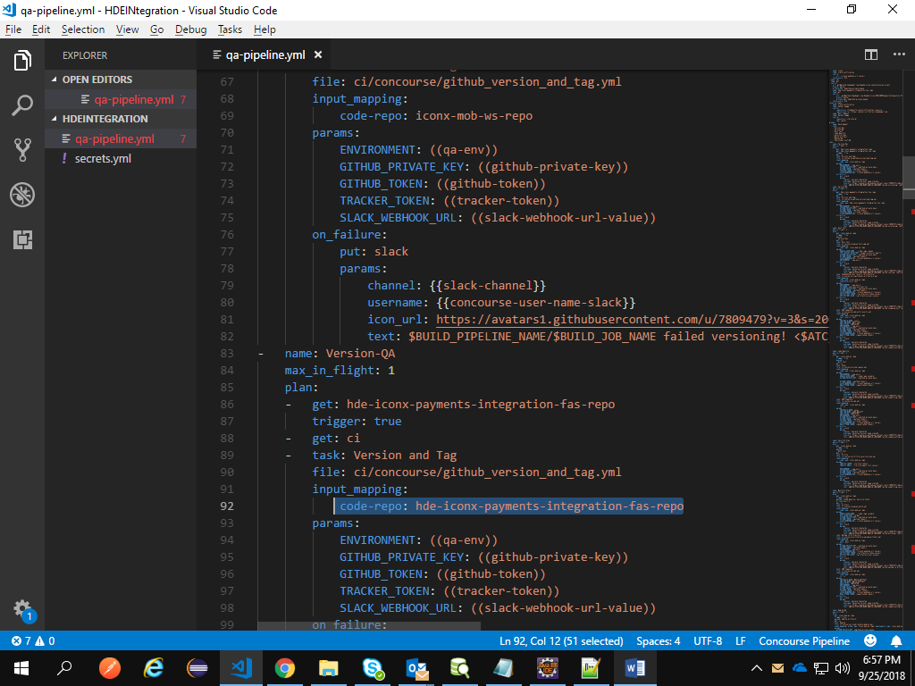

1. Update Dev repo name in line # 109 , 117,135,178 , 186 , 205,228,256, 264,281,300,323,342,364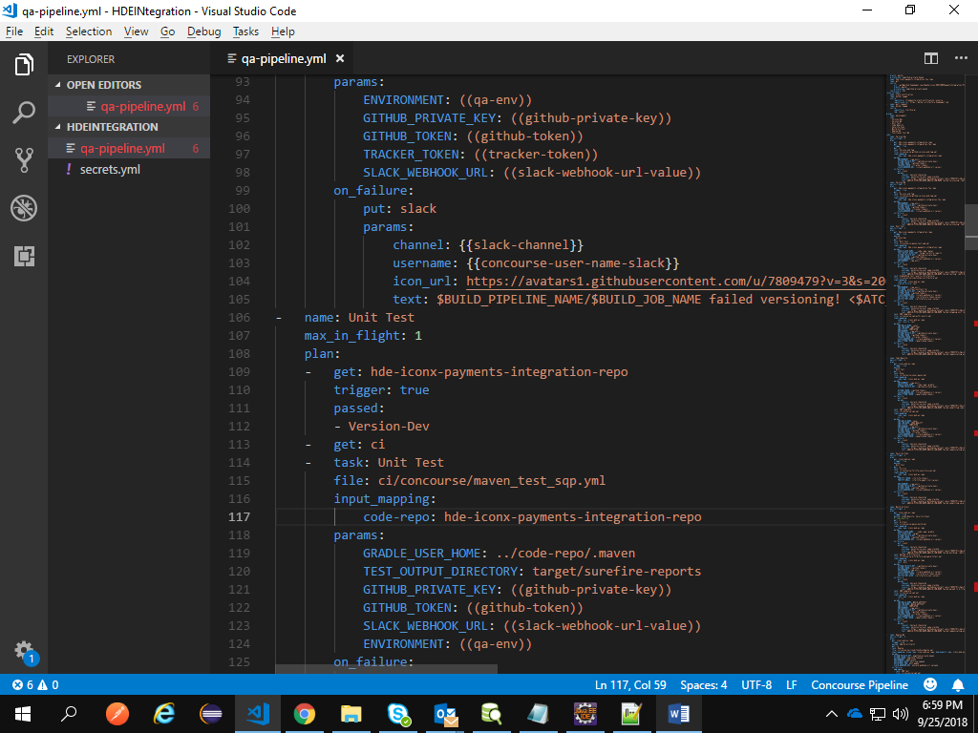
2. Update QA script repo name in line # 367 and 372

Please refer QA-pipeline.yml



1. Save yml in local and open that folder in command prompt

# Fly Commands to create pipeline in Concourse server

Follow below steps.

1. Add fly exe in the folder where you have both yml files. Download the fly according to the server version.



1. Run below command in the command prompt to initiate fly.

fly --target zoom login --team-name main --concourse-url http://ld02121.homedepot.com

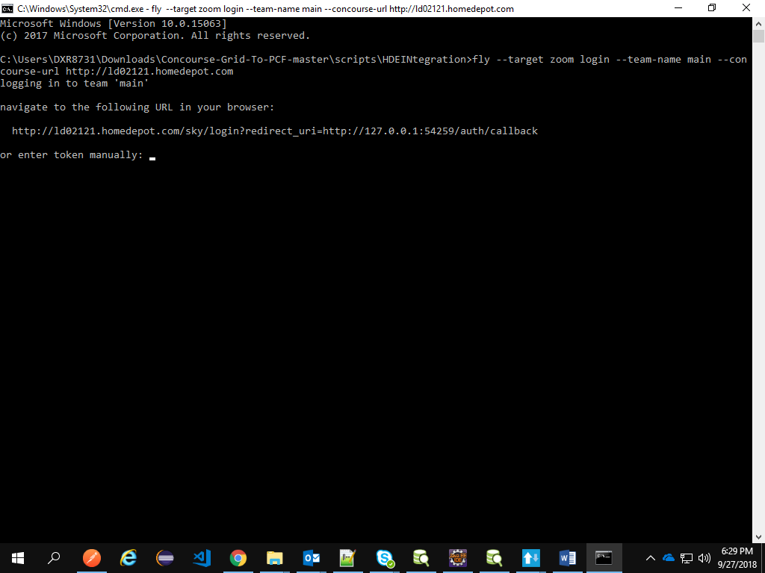

1. Open the browser and navigate the displayed URL from CMD prompt.
2. Run below command to create pipeline.

fly -t zoom sp -c qa-pipeline.yml -p doc-migration-batch -l secrets.yml

where doc-migration-batch is the pipeline name.

1. Open the Concourse using below URL and now you can able to see the pipelines created.

http://ld02121.homedepot.com/teams/main